



Loops with Copilot
LAB MANUAL

Disclaimer: The content is curated from online/offline resources and used for educational purpose only
Loops with Copilot – Number Guessing / Counting Game

Objective
By the end of this lab, you will be able to:
- Use GitHub Copilot to generate for and while loops in Python.
- Understand how loops repeat actions efficiently (repetition in code).
- Build a simple interactive game or counting program with user input and conditions.
- Compare writing loops manually vs. letting Copilot suggest/generate them (to see time/effort saved).
- Practice prompting Copilot effectively with clear comments for better suggestions.
- Run, test, and slightly modify the code to see how loops behave.

Equipment Required
- Computer/Laptop with Windows, macOS, or Linux.
- Visual Studio Code (VS Code) installed.
- Python 3.10 or higher installed and added to PATH.
- GitHub Copilot extension installed and activated in VS Code (signed in with GitHub account).
- Internet connection (for Copilot suggestions; offline mode limited).

Prerequisites
- Completed Module 3 fully (setup of VS Code + Python + Copilot, basic scripts with print/input).
- Comfortable creating .py files, running code in VS Code terminal (F5 or "Run Python File").
- Basic understanding of variables, if-else (from Module 3 or earlier).
- GitHub account signed in to VS Code with Copilot enabled (status bar shows Copilot icon active).
- Know how to accept Copilot suggestions (Tab key), reject (Esc), or choose alternatives (arrows).

Procedure
Follow these steps carefully.
- Preparation
  - Open VS Code.
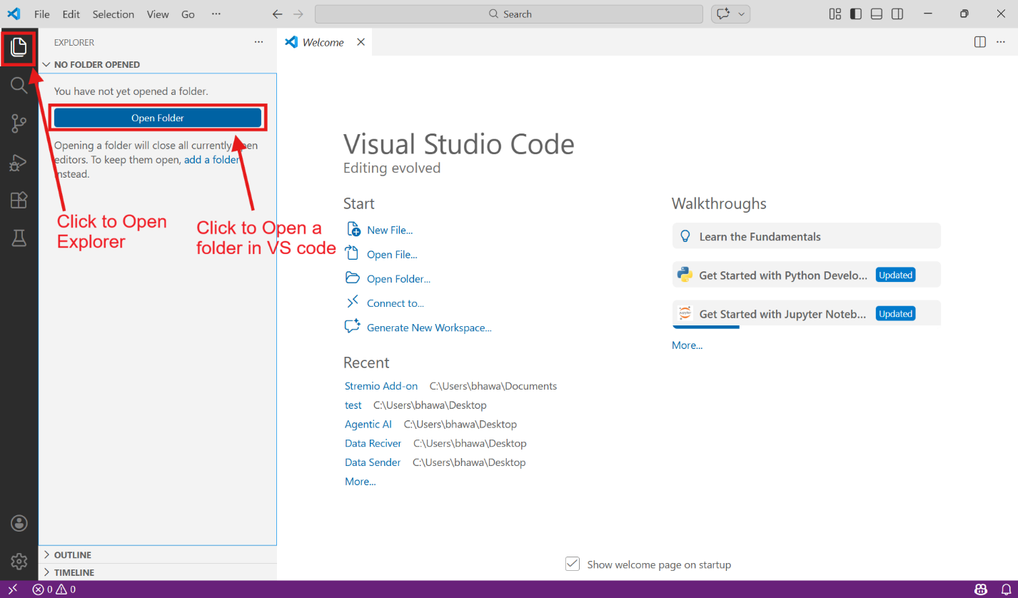
  - Create a new folder for Module 4 labs (e.g., "Module4_Labs").
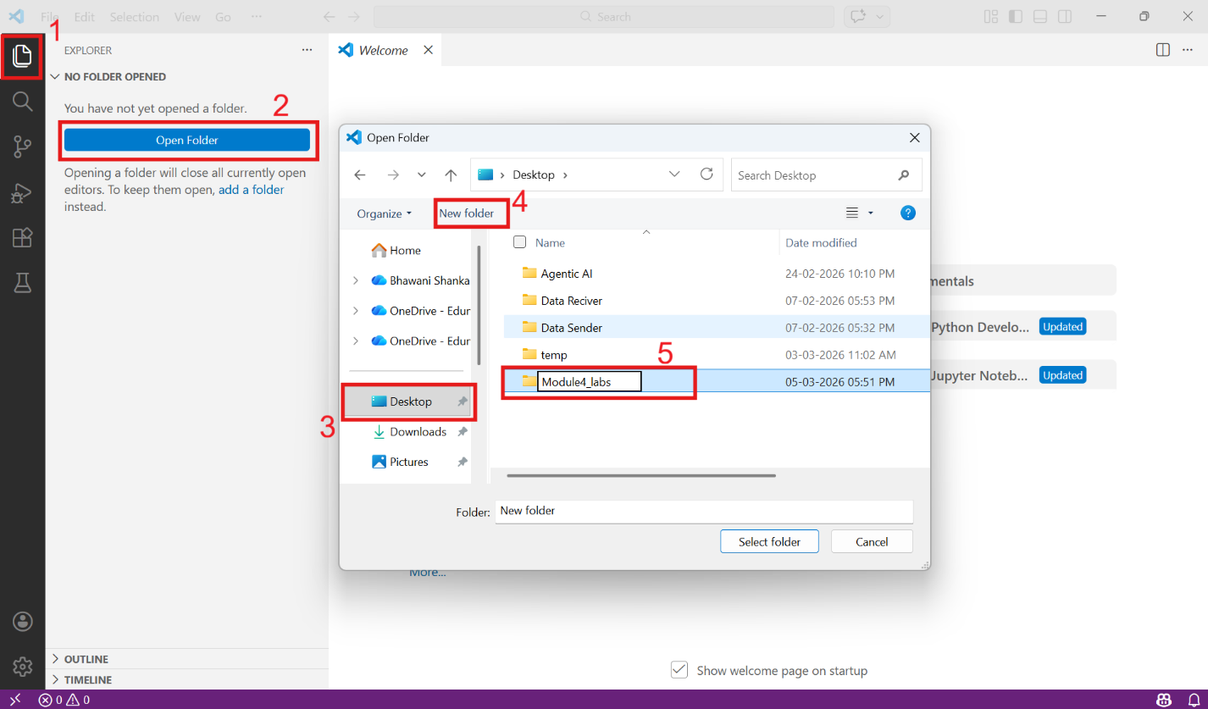
  - Inside it, create a new file named lab1_loops_game.py.
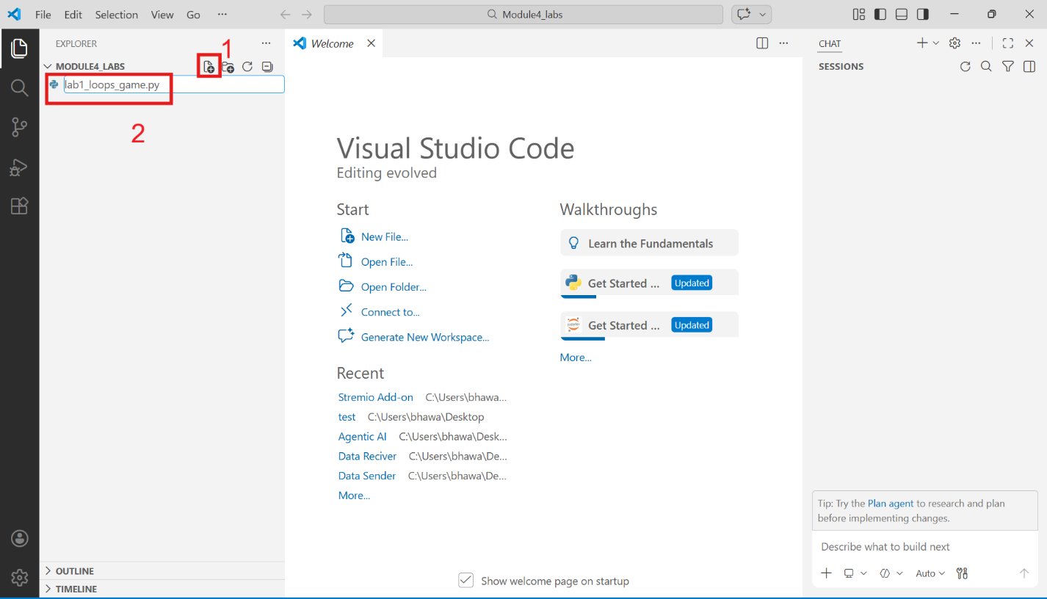

  - Save the file (Ctrl+S). Ensure Python interpreter is selected (bottom-left status bar).
  - In the file, type a comment at the top:
# Lab 1: Loops with Copilot - Number Guessing and Counting Game
# Objective: Use Copilot to create for and while loops
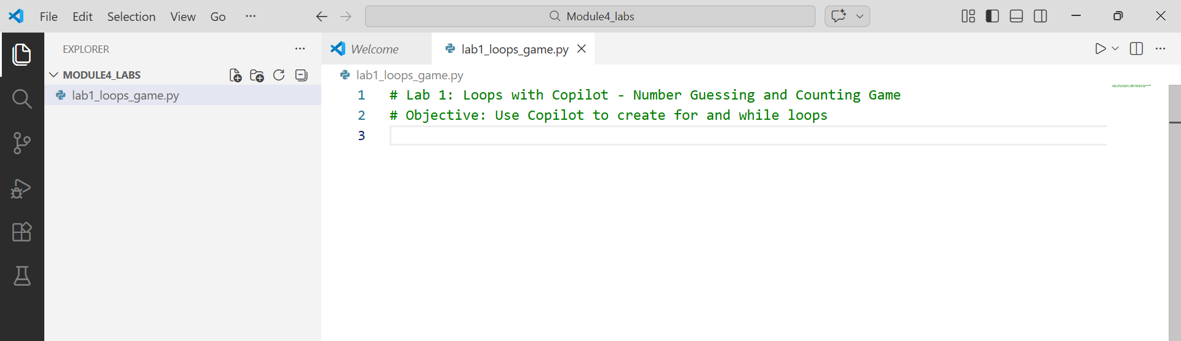
- Part A: Simple Counting with For Loop
  - Type this comment and press Enter:
# Use a for loop to print numbers from 1 to 20
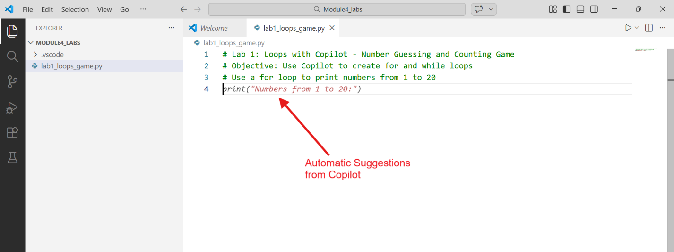
  - Copilot should suggest a for loop (e.g., for i in range(1, 21): print(i)).
    - Press Tab to accept if good.
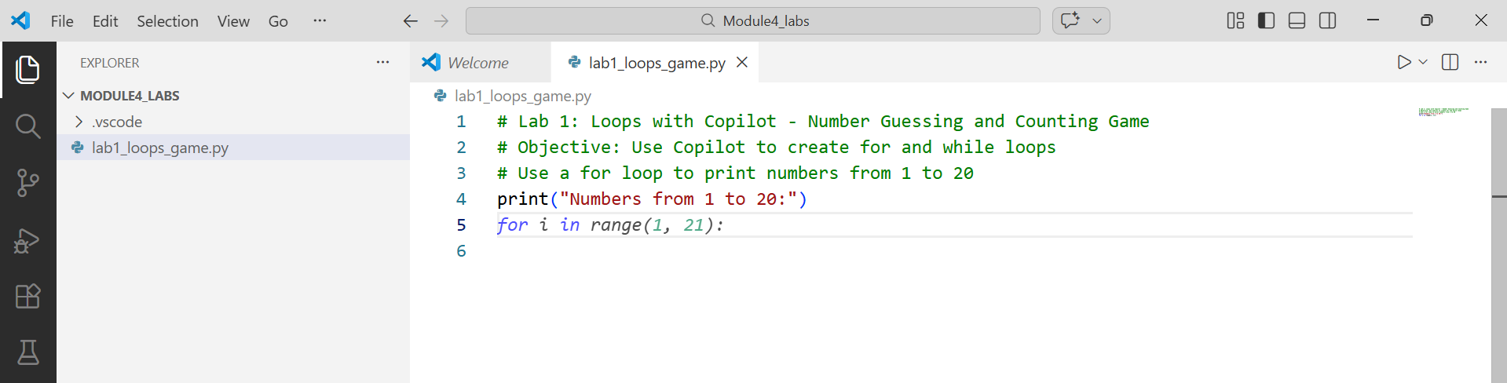
    - If not perfect, type more detail: # for loop to print even numbers from 2 to 20 and see new suggestion.
  - Run the code (right-click → Run Python File in Terminal or green play button).
  - Modify: Change to print only odd numbers (edit range or add if condition).
  - Observe: How many lines did Copilot write? How long manually? Note in your worksheet: "Copilot helped by..."
- Part B: Interactive Counting with While Loop (10–12 minutes)
  - Below the previous code, add comment:
# While loop: Keep asking user for a number until they enter 'stop'
# Print the number each time
  - Copilot may suggest:
while True:
num = input("Enter a number (or 'stop' to quit): ")
if num == 'stop':
break
print(num)
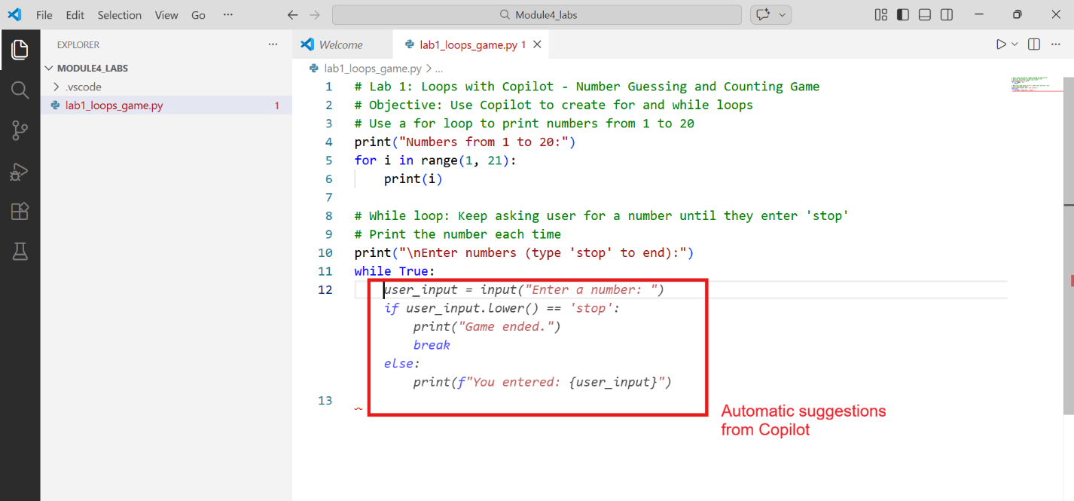
    - Accept and run. Test with inputs: 5, 10, stop.
  - Improve prompt if needed: # While loop to count how many times user enters a positive number, stop on negative
  - Add a counter variable (Copilot can help: # Add counter for positive numbers).
  - At end, print total positives entered.
- Part C: Mini Number Guessing Game with While Loop (15–18 minutes)
  - New section comment:
# Number Guessing Game using while loop
# Computer picks random number 1-100
# User guesses until correct, give hints (too high/low)
# Use Copilot to generate most of the code
  - First, import random: Type # Import random module → Copilot suggests import random.
  - Then prompt: # secret = random.randint(1, 100)
  - Main loop: # while loop for guessing: ask guess, check if == secret, give hint too high/low, count attempts
  - Copilot should generate something like:
import random

secret = random.randint(1, 100)
attempts = 0

print("Guess a number between 1 and 100!")

while True:
guess = int(input("Your guess: "))
attempts += 1
if guess == secret:
print(f"Correct! You took {attempts} attempts.")
break
elif guess < secret:
print("Too low!")
else:
print("Too high!")
  - Accept, run, and play 2–3 times.
  - Experiment: Add max attempts (e.g., 10) and break if exceeded. Prompt Copilot: # Add limit of 8 attempts, if exceed print secret and lose
- Reflection & Testing
  - Run full file. Fix any errors using Copilot (highlight error line → type # fix this or use Copilot Chat if available: Ctrl+Shift+I → ask "explain this error").
  - Note observations:
    - Which loop was easier with Copilot?
    - Best comment prompt you used?
    - One thing you learned about loops.

Conclusion
In this lab, you successfully used GitHub Copilot to generate and refine for and while loops without writing every line manually. Loops are essential for repetition - like counting items or waiting for correct input in games/apps. Copilot acted as an "AI teaching assistant" by suggesting correct syntax, logic, and even improvements when prompted clearly (e.g., detailed English comments).

